# 1 查询出只选修了一门课程的全部学生的学号和姓名

SELECT sc.sid,s.sname FROM student AS s INNER JOIN sc ON s.sid = sc.sid GROUP BY sc.sid HAVING COUNT(sc.sid) = 1

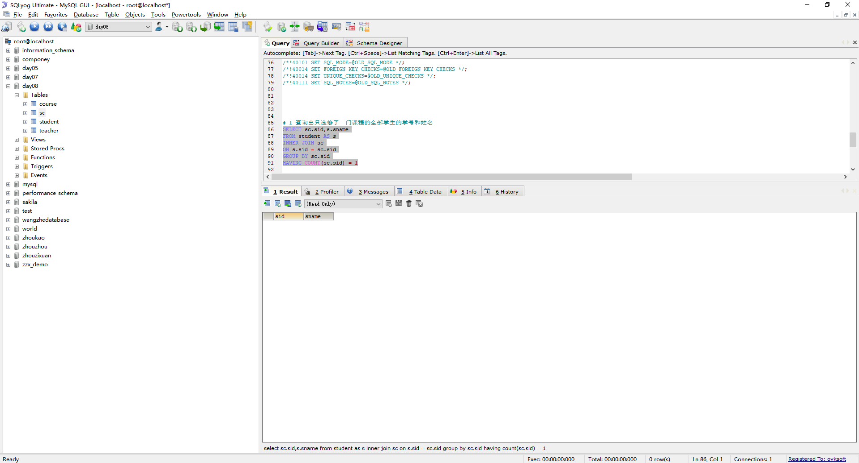

# 2 查询不同课程成绩相同的学生的学号、课程号、学生成绩

SELECT s1.sid,s1.cid,s1.score FROM sc AS s1 INNER JOIN sc AS s2 WHERE s1.cid <> s2.cid AND s1.score = s2.score;

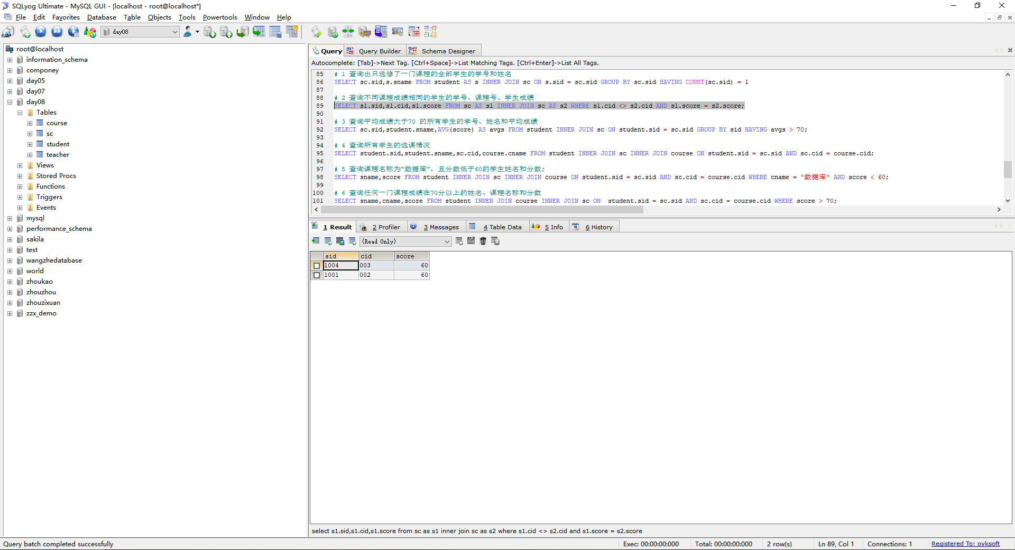

# 3 查询平均成绩大于70 的所有学生的学号、姓名和平均成绩

SELECT sc.sid,student.sname,AVG(score) AS avgs FROM student INNER JOIN sc ON student.sid = sc.sid GROUP BY sid HAVING avgs > 70;

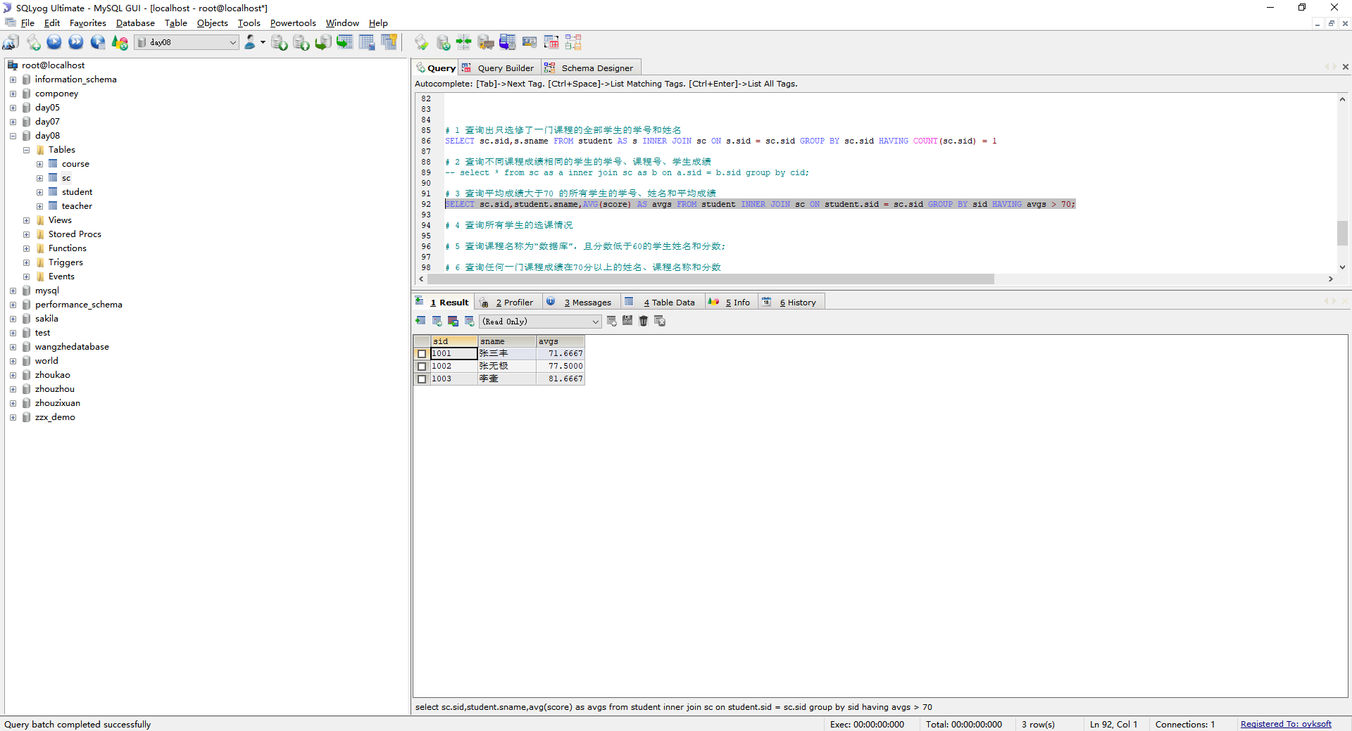

# 4 查询所有学生的选课情况

SELECT student.sid,student.sname,sc.cid,course.cname FROM student INNER JOIN sc INNER JOIN course ON student.sid = sc.sid AND sc.cid = course.cid;

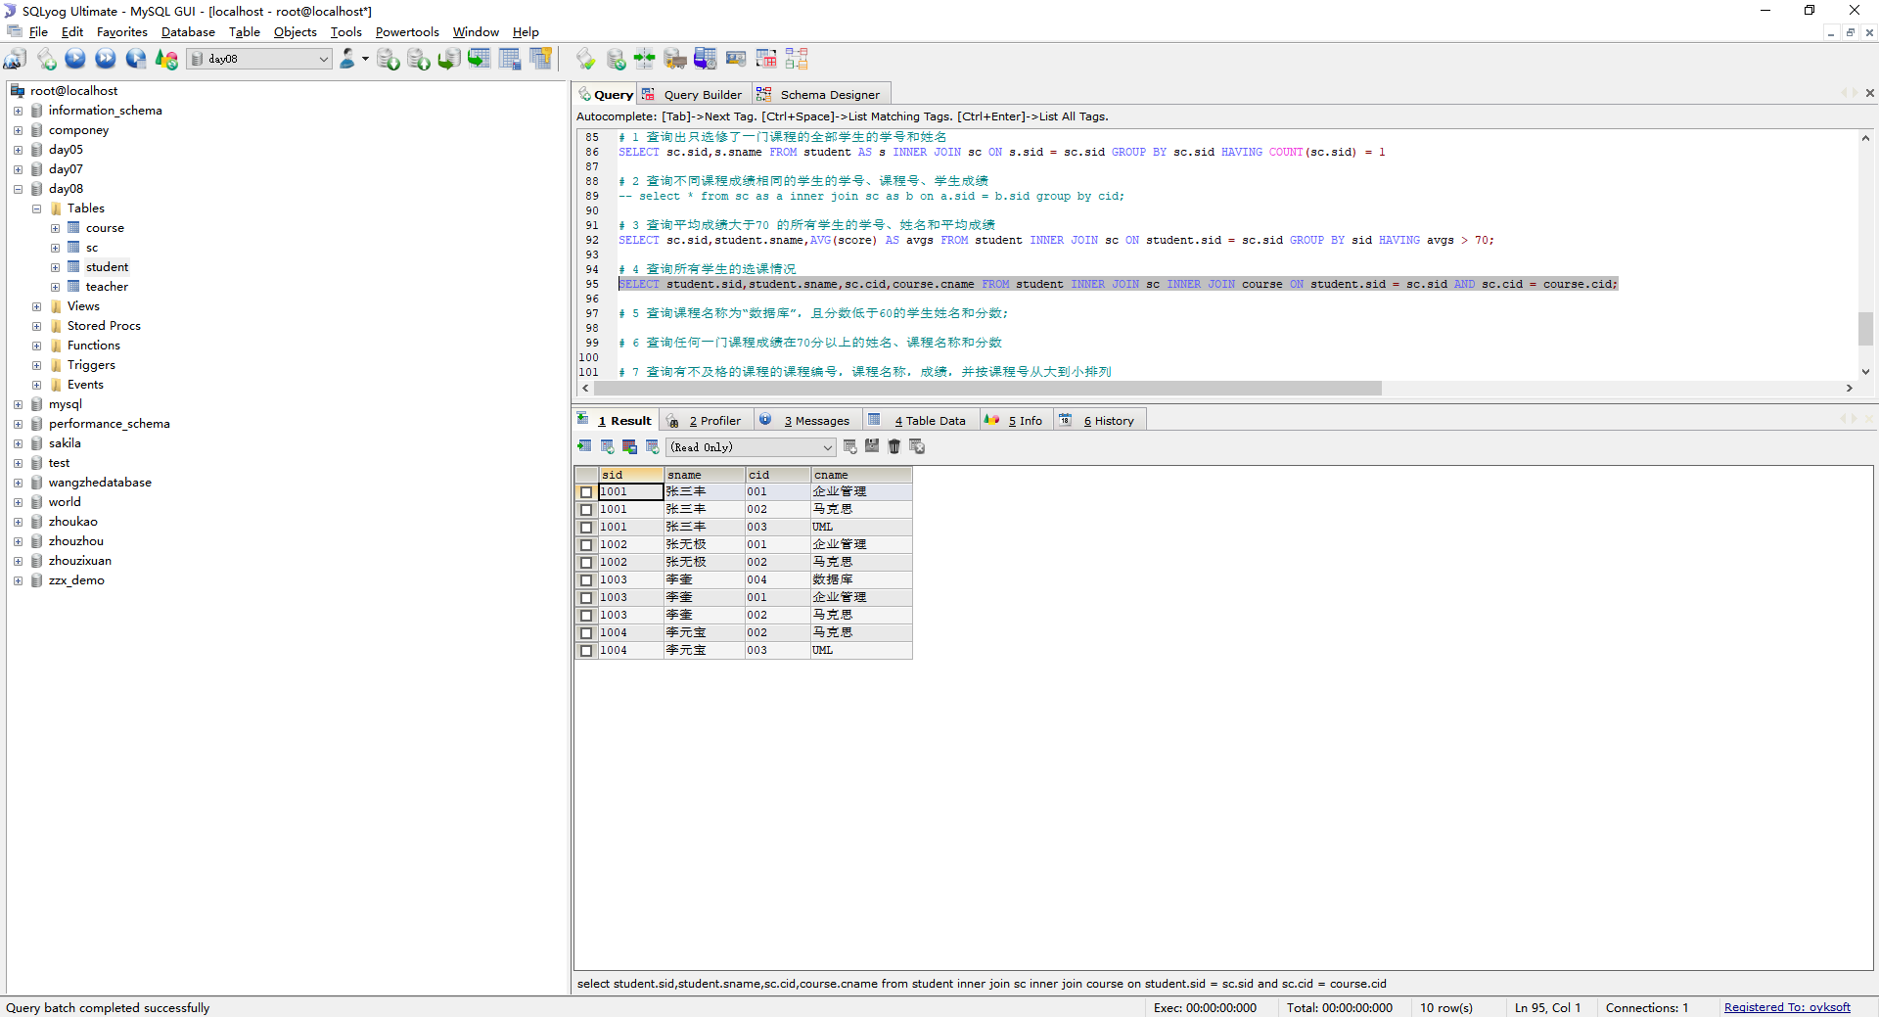

# 5 查询课程名称为“数据库”，且分数低于60的学生姓名和分数;

select sname,score from student inner join sc inner join course on student.sid = sc.sid and sc.cid = course.cid where cname = '数据库' and score < 60;

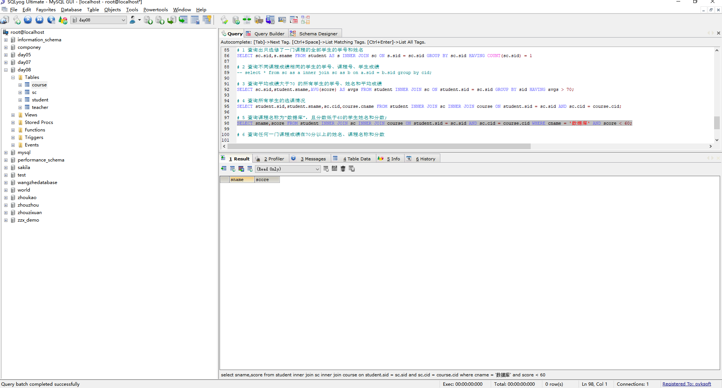

# 6 查询任何一门课程成绩在70分以上的姓名、课程名称和分数

SELECT sname,cname,score FROM student INNER JOIN course INNER JOIN sc ON student.sid = sc.sid AND sc.cid = course.cid WHERE score > 70;

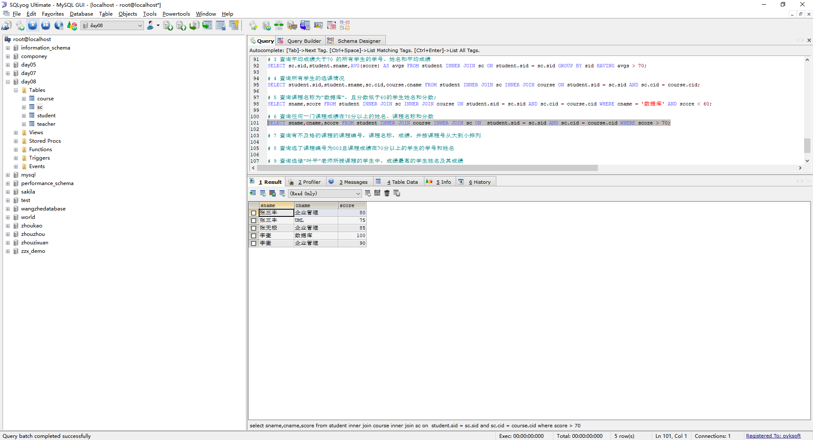

# 7 查询有不及格的课程的课程编号，课程名称，成绩，并按课程号从大到小排列

SELECT c.cid,cname,score FROM sc AS s INNER JOIN course AS c ON s.cid = c.cid WHERE score < 60 ORDER BY score DESC;

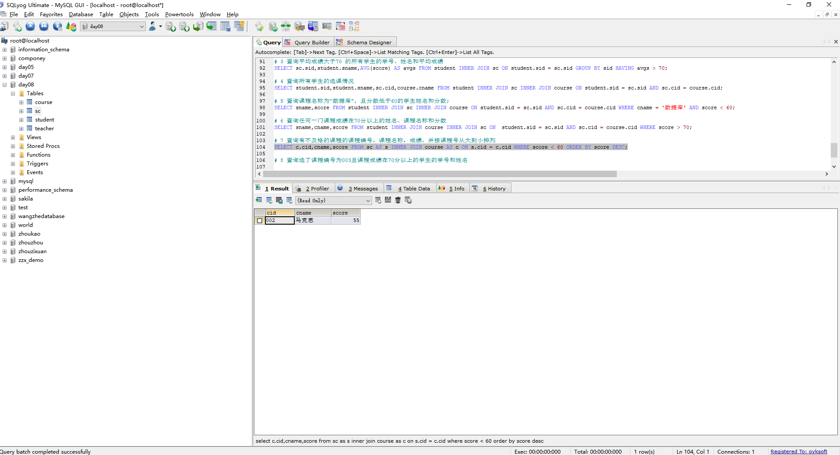

# 8 查询选了课程编号为003且课程成绩在70分以上的学生的学号和姓名

SELECT student.sid,sname FROM student INNER JOIN sc ON student.sid = sc.sid WHERE cid = 003 AND score > 70;

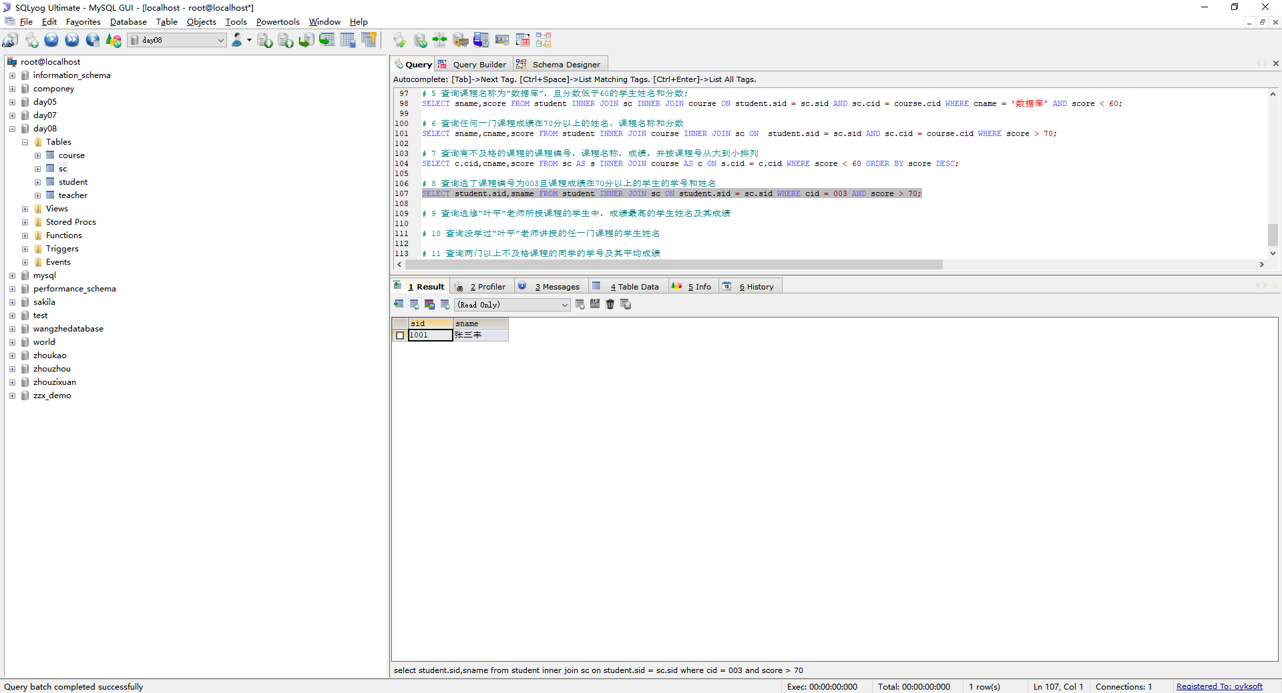

# 9 查询选修“叶平”老师所授课程的学生中，成绩最高的学生姓名及其成绩

SELECT sname,cname,score FROM teacher INNER JOIN course INNER JOIN student INNER JOIN sc ON teacher.tid = course.tid AND course.cid = sc.cid AND sc.sid = student.sid

AND

score IN(SELECT MAX(score) FROM teacher INNER JOIN course INNER JOIN student INNER JOIN sc ON teacher.tid = course.tid AND course.cid = sc.cid AND sc.sid = student.sid WHERE tname = '叶平' GROUP BY cname);

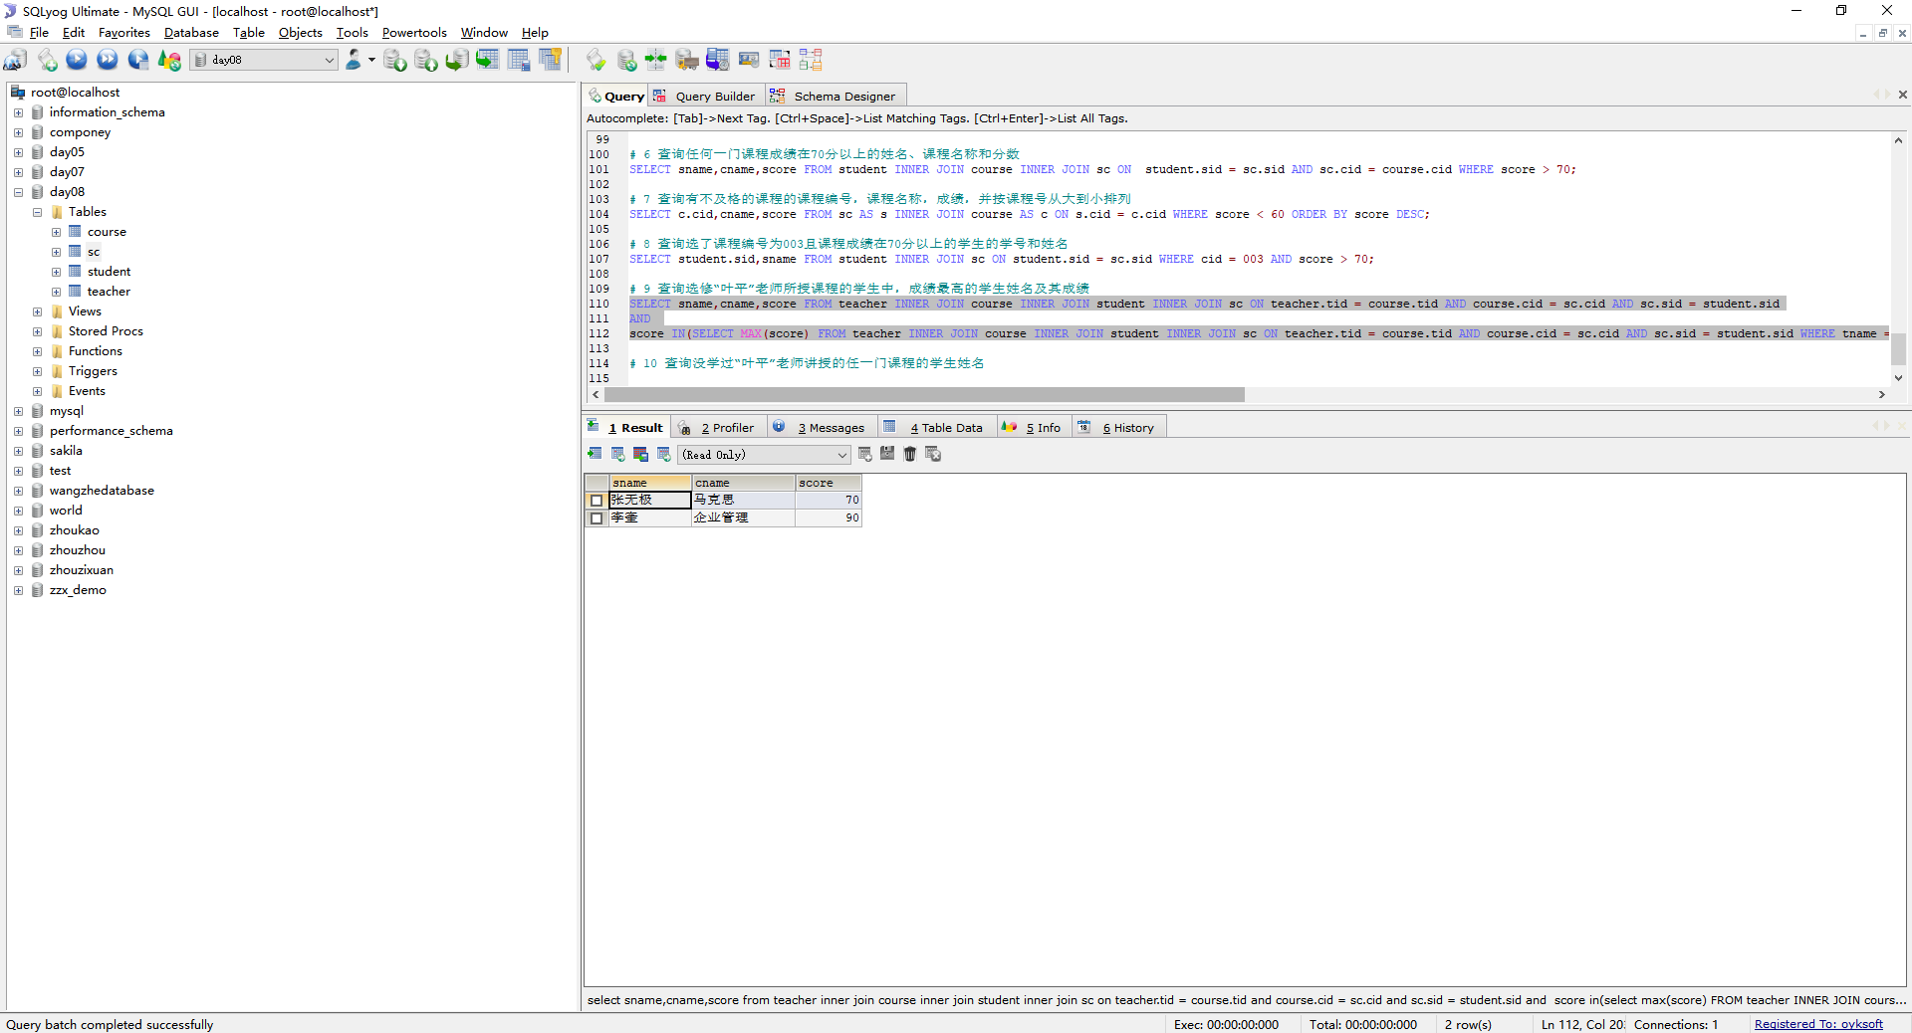

# 10 查询没学过“叶平”老师讲授的任一门课程的学生姓名

SELECT student.sid,sname FROM student WHERE student.sid NOT IN(SELECT student.sid FROM teacher INNER JOIN course INNER JOIN student INNER JOIN sc ON teacher.tid = course.tid AND course.cid = sc.cid AND sc.sid = student.sid WHERE tname = '叶平')

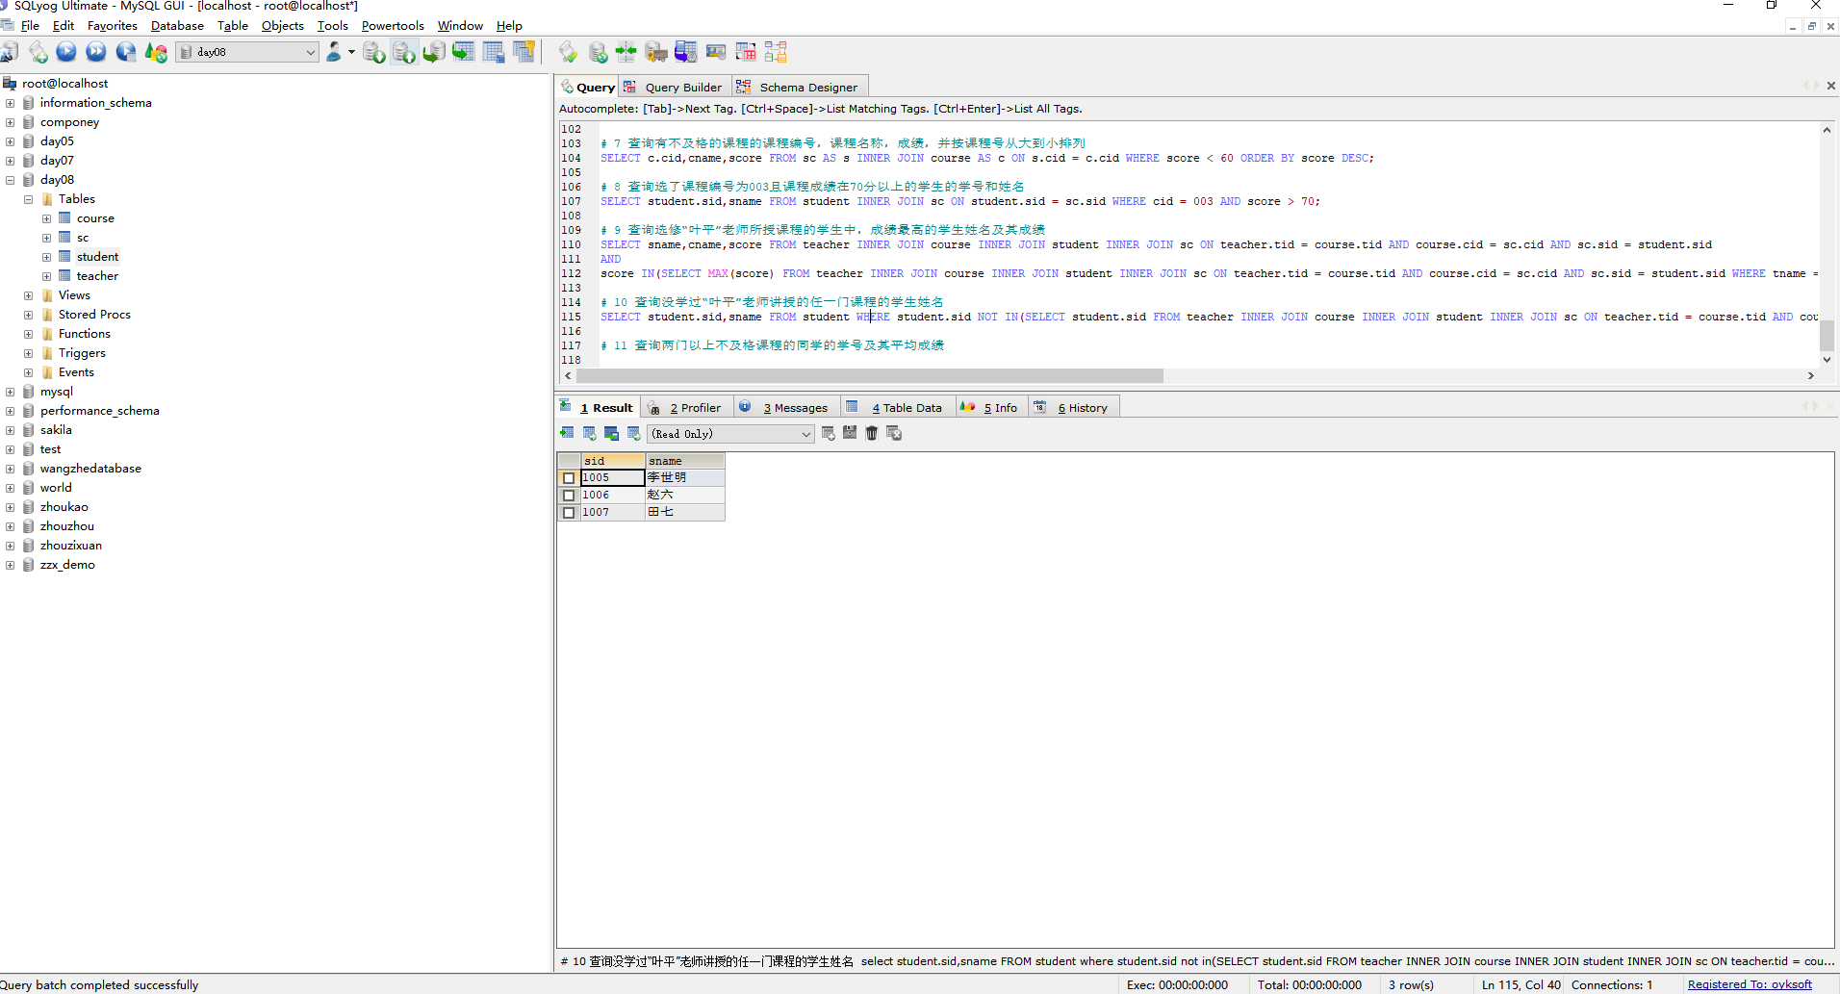

# 11 查询两门以上不及格课程的同学的学号及其平均成绩

SELECT sid,AVG(score),COUNT(*) FROM sc WHERE score < 60 GROUP BY sid HAVING COUNT(*) > 2;

